**Proba- Homework – Version Control Systems**

1. **Subversion(SVN)**
   * Now that you are aware of git, you can take a look to the second most popular version control – SVN
   * Firstly, you must install SVN to your machine - Depending on the OS you have a couple of choices
     1. Windows - <https://sourceforge.net/projects/win32svn/>
     2. Mac – best to install a piece of software called “Homebrew” (Google it) and then run from your command line “brew install svn” (without the “)

-<http://stackoverflow.com/questions/19921714/command-line-svn-client-for-mac>

* + 1. Linux – depending of your distro – you will have a specific package manager

Ex. For *Ubuntu, Debian, Elementary OS the command will be “sudo apt-get install subversion” (without the “)

* *Make sure svn is in your Environment Variables – Path

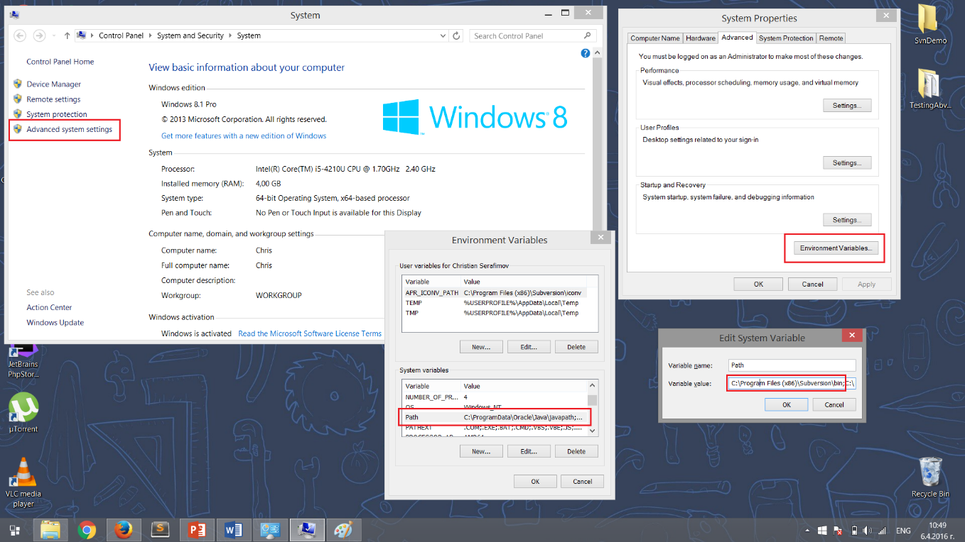

*Specific for windows

* Open terminal/Command Prompt and type svn help – you should get a list of commands

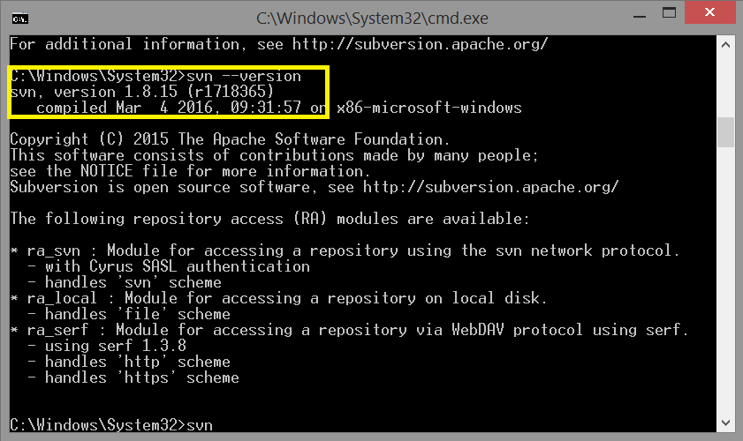

* Now from the lecture you should know that SVN is centralized that means that you have only a remote repo and a working copy

(no local repo).

* So go and create a new GitHub repository
* Navigate to the newly created repo and copy the link
* Now create a folder where you would like the working copy to stay
* Navigate through the command line to the newly create folder, using

cd {folder_name} – to navigate to a new directory

ls *or* dir – to get a list of the current directories

cd .. – to return one folder back

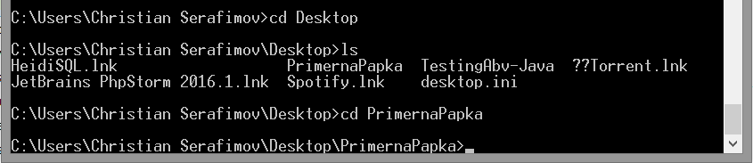

* It’s time for commands

svn checkout {link_to_github_repo} .

*This will create a working copy from the project to your computer (like git clone). If you don’t add the dot(.) it will create a new folder with the name of the repo.

--Create a file, modify it, experiment

svn add . --force

If you have added new files, this command will tell svn to include them

svn commit –m “{message}”

This will make a commit to the remote repo(GitHub)

--Update some file from the GitHub Website, then…

svn update

This will get the latest changes from the repo to your working copy.

svn status

Tells you the status of all changed or added files

* Finally create a .txt file add your GitHub repo ***link*** and send it to the SoftUni system.